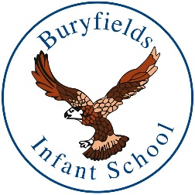

BURYFIELDS AND MAYHILL SCHOOL
CHRISTMAS BAUBLE
£12.50 each

Christmas bauble pre-sale
available from The Frame Odiham

Buryfields PTA and Mayhill FOM will receive a percentage of all sales!

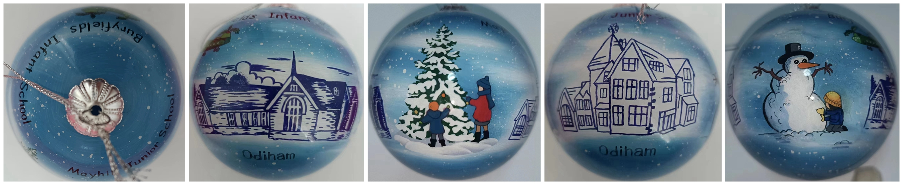
(Images above showing all sides of the 1 school bauble)

3 options to pre-order your Buryfields and Mayhill Christmas Bauble by Sunday 26th November (Odiham Extravaganza):

- Pop into The Frame Gallery (opposite Bel and the Dragon)

- Phone The Frame Gallery on 01256 701082

- Email The Frame Gallery at hello@theframe-gallery.co.uk

